PROGRAM CODE
#include<stdio.h>
int pn;
int pno[10],at[10],bt[10],ct[10],tat[10],wt[10],rt[10];
float avg_waiting,avg_turnaround,avg_response;
int twt = 0,ttat = 0,trt = 0,curt = 0;
void sortAT();
void sortBT();
void calc_SJF();
void printTable();
void main()
{
printf("Number of Processes = ");
scanf("%d", &pn);
for (int i = 0; i < pn; i++)
{
pno[i]=i+1;
printf("[Processes %d][AT] - ",i+1);
scanf("%d", &at[i]);
printf("[Processes %d][BT] - ",i+1);
scanf("%d", &bt[i]);
}
sortAT(pn);
sortBT(pn);
calc_SJF(pn);
printTable(pn);
}
void sortAT(int n)
{
for (int i = 0; i < n - 1; i++)
{
for (int j = 0; j < n - i - 1; j++)
{
if (at[j] > at[j + 1])
{
int temp_pno = pno[j];
pno[j] = pno[j + 1];
pno[j + 1] = temp_pno;
int temp_at = at[j];
at[j] = at[j + 1];
at[j + 1] = temp_at;
int temp_bt = bt[j];
bt[j] = bt[j + 1];
bt[j + 1] = temp_bt;
}
}
}
}
void sortBT(int n)
{
for (int i = 1; i < n - 1; i++)
{
for (int j = 1; j < n - i; j++)
{
if (bt[j] > bt[j + 1])
{
int temp_pno = pno[j];
pno[j] = pno[j + 1];
pno[j + 1] = temp_pno;
int temp_at = at[j];
at[j] = at[j + 1];
at[j + 1] = temp_at;
int temp_bt = bt[j];
bt[j] = bt[j + 1];
bt[j + 1] = temp_bt;
}
}
}
}
void calc_SJF(int n)
{
int completed=0;
for (int i = 0; i < n; i++) {
ct[i] = curt + bt[i];
tat[i] = ct[i] - at[i];
wt[i] = tat[i] - bt[i];
rt[i] = wt[i];
curt += bt[i];
completed++;
twt += wt[i];
ttat += tat[i];
trt += rt[i];
}
avg_waiting = (float)twt / n;
avg_turnaround = (float)ttat / n;
avg_response = (float)trt / n;
}
void printTable(int n)
{
printf("\n+------------+--------------+------------+-----------------+-----------------+--------------+---------------+\n");
printf("| Process ID | Arrival Time | Burst Time | Completion Time | Turnaround Time | Waiting Time | Response Time |\n");
printf("+------------+--------------+------------+-----------------+-----------------+--------------+---------------+\n");
for (int i = 0; i < n; i++)
{
printf("| %10d | %12d |%11d | %15d | %14d |%13d |%14d |\n",pno[i],at[i],bt[i],ct[i],tat[i],wt[i],rt[i]);
}
printf("+------------+--------------+------------+-----------------+-----------------+--------------+---------------+\n");
printf("\nAverage Turn Around Time = %.2f\n", avg_turnaround);
printf("Average Waiting Time = %.2f\n", avg_waiting);
printf("Average Response Time = %.2f\n", avg_response);
}

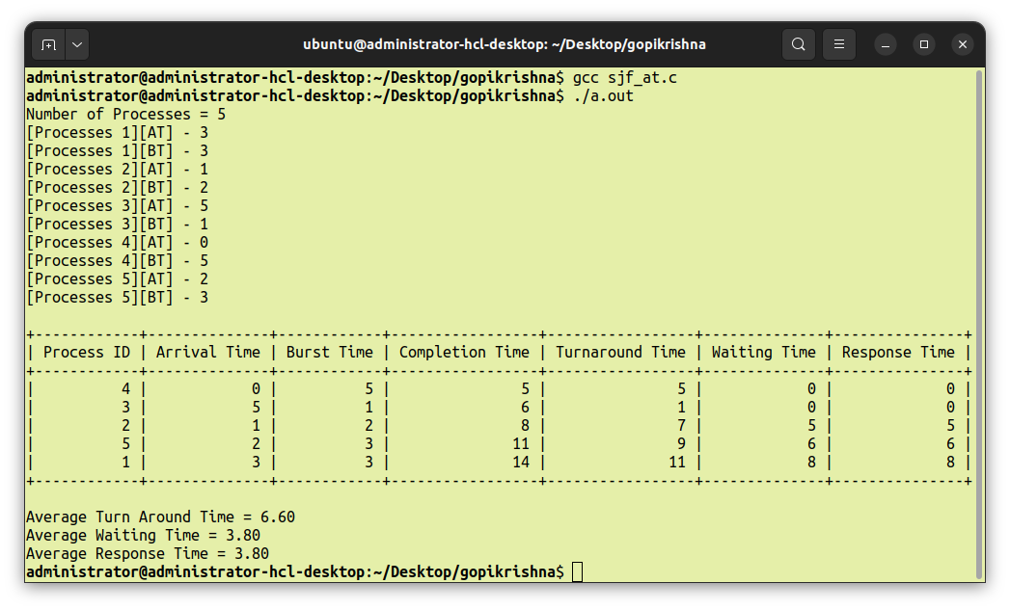
OUTPUT

